CSE 564 Project Report Number 6

Team 21

Team Member Names:

1. Parv Shah

2. Monil Rameshchandra Prajapati

3. Alexander Chittim

4. Prathit Barot

5. Brenden Martinez

Table of Contents

Table of Contents ii

1. The Problem 1

1.1. Description 1

1.2. Previous and current attempts at a solution 2

2. A Vision for a Solution 4

2.1. Overview 4

2.2. Solution Concept 4

3. Requirements 6

3.1. Introduction 6

3.2. Operational Requirements 6

3.3. Quality Requirements 9

4. Architecture 12

4.1. Architectural Overview 12

4.2. Interaction Model 12

4.3. Architectural Views 16

4.3.1. Architectural View 1 Logical View 16

4.3.2. Architectural View 2 Physical View 20

4.3.3. Architectural View 2 Development View 22

5. Detailed Design 26

5.1. System Context and Interactions 26

5.1.1. Design Element 1: LidarView 27

5.1.2. Design Element 2: User interaction and Feedback Module 32

5.1.3. Design Element 3: Adjusting System Preferences 37

6. Implementability 41

6.1. Overview 41

6.2. Structure and Naming 43

6.3. Use Case Implementability Analysis and Rationale 44

6.4. Implementability Details 46

7. Presentations 48

7.1. Overview Screencast 48

7.2. Detailed Presentation of Flow and Implementability 48

8. Conclusion 49

8.1. Overview 49

8.2. Lessons Learned 49

8.3. Recommendations for Improvement 49

9. Appendix A: Credit Sheet 50

1. The Problem
   1. Description

Visually impaired individuals face significant challenges when navigating urban environments independently. The dynamic nature of urban landscapes, coupled with the limitations of traditional mobility aids, such as canes and guide dogs, contributes to the difficulties encountered by this demographic. These challenges are particularly pronounced in crowded or changing urban settings, where real-time information about the immediate environment is crucial for safe navigation.

* 1. Previous and current attempts at a solution
     1. Traditional Mobility Aids
        1. Example: White canes and guide dogs.
        2. Limitations: These aids lack the ability to provide detailed, real-time information about the immediate environment, especially in crowded or changing urban settings.
     2. Assistive Technologies
        1. Example: Existing GPS-based navigation devices.
        2. Limitations: While these devices offer some assistance, they often fall short of providing comprehensive environmental awareness, particularly in scenarios where precise obstacle detection is crucial.
     3. Limited Feedback Mechanisms
        1. Example: Devices with basic obstacle detection.
        2. Limitations: Current solutions may detect obstacles but provide limited proactive alerts, leaving users unaware of potential hazards in their path.
     4. Incomplete Integration
        1. Example: Systems with disconnected hardware and software components.
        2. Limitations: Lack of seamless communication between the LIDAR sensor, data processing software (LidarView), and user interface components (mobile application and wearables). This fragmentation hinders the effectiveness of the overall system.
     5. User Interface Challenges
        1. Example: Interface designs not optimized for voice and gesture interactions.
        2. Limitations: Current interfaces may not be intuitive for visually impaired users, hampering their ability to interact seamlessly with the assistive system.
  2. Organizations Affected

The issues of accessibility faced by visually impaired individuals in urban environments impact various organizations, including but not limited to

* + - 1. Urban Planning Departments
      2. Transportation Services
      3. Accessibility Advocacy Groups
    1. Previous and Current Attempts by Organizations

These organizations have made efforts to address the challenges faced by visually impaired individuals:

* + - 1. Urban Planning Departments:

Urban Planning Departments have undertaken initiatives such as the implementation of tactile pavement indicators and audible signals at crosswalks. These measures aim to enhance the navigational experience for visually impaired individuals by providing tactile cues and auditory signals at key points in urban landscapes.

* + - 1. Transportation Services: Providing traditional mobility aids and basic GPS navigation devices.
      2. Accessibility Advocacy Groups: Conducting awareness campaigns and advocating for inclusive urban design.
    1. Why Previous Attempts Are Unsatisfactory

Previous attempts to address the challenges faced by visually impaired individuals in urban environments, while indicative of an acknowledgment of the issue, exhibit shortcomings on several fronts.

These inadequacies include a deficiency in providing real-time and detailed environmental information, a lack of proactive alerts and feedback mechanisms, fragmented integration between hardware and software components, and a limited consideration of the unique needs of visually impaired individuals in dynamic urban settings.

The collective effect of these limitations diminishes the efficacy of existing solutions, emphasizing the imperative for a more comprehensive and nuanced approach to better serve the diverse requirements of this user group in dynamic urban landscapes.

1. A Vision for a Solution
   1. Overview

In a world that is becoming increasingly interconnected and complex, the challenges faced by visually impaired individuals in navigating their surroundings are manifold. The absence of a comprehensive and intuitive guidance system often translates to barriers in mobility, independence, and the ability to engage fully with the environment. Recognizing this pressing need, our vision is to introduce a transformative LiDAR-based guidance system, redefining the possibilities for those with visual impairments.

* + 1. Introduction to the Vision

The core of our vision is grounded in the belief that technology should be an enabler of inclusivity and empowerment. Visually impaired individuals encounter not only physical obstacles but also the psychological barriers of navigating unfamiliar or dynamic spaces. Our vision seeks to transcend the limitations of existing solutions by harnessing the power of LiDAR technology. This isn't just about assistance; it's about providing a holistic tool that empowers individuals to navigate the world with newfound confidence and independence.

* 1. Solution Concept

The challenges faced by the visually impaired extend beyond mere physical impediments; they touch upon fundamental aspects of independence and the freedom to explore. Traditional navigation aids often fall short in providing a comprehensive solution. Our vision aims to address this gap comprehensively. By delving into the nuanced aspects of the problem, we lay the groundwork for a solution that not only guides but also fosters autonomy, resilience, and an enhanced quality of life.

* + 1. The Human-Centric Approach

At the heart of our vision is a commitment to a human-centric approach. We envision a solution that goes beyond the utilitarian aspects of obstacle avoidance; it's about creating an experience that is intuitive, responsive, and seamlessly integrated into the user's daily life. By understanding the unique needs and challenges faced by visually impaired individuals, we aim to design a system that not only meets functional requirements but also enhances the overall well-being of its users.

* + 1. Ethical Considerations

As we dive into creating a LiDAR-based guidance system to assist visually impaired individuals, we're putting a strong focus on doing what's right. Our commitment to ethics isn't just a formality – it's like our North Star, guiding every step we take. Here's how we're making sure our project is not just good, but ethically solid.

* + - 1. Societal Impact

Our ethical compass extends to the broader societal impact of the technology. We recognize the potential for societal shifts and actively work to mitigate unintended consequences. This involves considering the economic, cultural, and environmental implications of widespread adoption and ensuring that the benefits are equitably distributed.

1. Requirements
   1. Introduction

The development of a LiDAR-based guidance system for visually impaired individuals is driven by a commitment to address the unique challenges faced by this community. The requirements outlined in this section serve as the foundation for the LidarView project, ensuring that the system is not only technically robust but also aligns with the specific needs and expectations of its users. By defining clear and comprehensive requirements, we aim to guide the design and implementation phases towards the creation of a solution that enhances mobility, independence, and overall well-being for individuals with visual impairments.

* 1. Operational Requirements
     1. Requirement 1
        1. Feature:
           + Environmental Awareness
        2. Description:

The system must empower visually impaired users in urban environments by delivering real-time, granular information about their surroundings. This includes details about nearby obstacles, intersections, and points of interest, enhancing users' situational awareness. The system's capability to provide this information is fundamental to ensuring users can navigate their surroundings confidently and independently.

* + - 1. Requirement Source:

Adapted from the World Health Organization’s World Report on Vision [[World Vision report](https://www.who.int/docs/default-source/documents/publications/world-vision-report-accessible.pdf), Page 55]

* + 1. Requirement 2
       1. Feature:
          - User Navigation Assistance
       2. Description:

The system is tasked with providing comprehensive navigation assistance to visually impaired users. This encompasses turn-by-turn directions, real-time obstacle detection, and intelligent route optimization based on user preferences and environmental conditions.

* + - 1. Requirement Source:

In accordance with the International Electrotechnical Commission (IEC) Standard on Assistive Technologies [[Guide for addressing accessibility in standards](https://www.iec.ch/webstore/freepubs/isoiecguide71%7Bed2.0%7Den.pdf), Section 7]

* + 1. Requirement 3
       1. Feature:
          - Voice Recognition
       2. Description:

Voice recognition technology will be seamlessly integrated into the system, enabling users to interact with the interface using natural spoken commands. This feature enhances accessibility and user engagement.

* + - 1. Requirement Source:

Based on Why we need to get more people with disabilities involved in developing technology [[World Economic Forum Report](https://www.weforum.org/agenda/2021/06/people-with-disabilities-developing-technology/)]

* + 1. Requirement 4
       1. Feature:
          - Proactive Hazard Alerts
       2. Description:

The system is designed to go beyond passive navigation by providing proactive alerts to users about potential hazards or obstacles in their path. This ensures users have sufficient time to take preventive action, contributing to overall safety.

* + - 1. Requirement Source:

Derived from the U.S. Access Board's guidelines for Electronic and Information Technology Accessibility Standards [[508 Standards and 255 Guidelines](https://www.access-board.gov/ict/#508-chapter-1-application-and-administration), Section 508]

* + 1. Requirement 5
       1. Feature:
          - Seamless Integration
       2. Description:

Ensuring a cohesive user experience, the system components, including the LIDAR sensor, LidarView software, and user interface, will be seamlessly integrated. This integration aims for efficient communication and functionality, fostering a user-friendly and inclusive interaction.

* + - 1. Requirement Source:

Adopted from the IEEE Standard for Accessible and Usable Design of Software Interfaces [[IEEE/ISO/IEC 26514:2022 - Systems and software engineering Design](https://www.iso.org/obp/ui/#!iso:std:77451:en), Clause 7]

* 1. Quality Requirements
     1. 3.1. Usability
        1. Description

The system must exhibit a high level of usability, ensuring that visually impaired users can efficiently interact with the interface. This includes features such as intuitive menu structures, clear navigation paths, and voice command responsiveness. Usability testing will involve individuals with varying degrees of visual impairment to validate the system's effectiveness.

* + - 1. Requirement Source

[Aligned with the principles of Universal Design for digital interfaces [ISO 9241-210:2019]](https://www.iso.org/obp/ui/en/#iso:std:iso:9241:-210:ed-2:v1:en)

* + 1. Reliability
       1. Description

The system must operate with a high degree of reliability, minimizing downtime and errors. It should handle unexpected scenarios, such as temporary signal loss from the LIDAR sensor, ensuring continuous functionality. Reliability testing will include stress testing and simulated failure scenarios.

* + - 1. Requirement Source

[Derived from established guidelines for reliable software systems [ISO/IEC/IEEE 26531:2015]](https://www.iso.org/obp/ui/en/#iso:std:iso-iec-ieee:26531:ed-2:v1:en)

* + 1. Adaptability
       1. Description

The system should demonstrate adaptability to diverse urban environments. It must dynamically adjust its behavior based on the specific characteristics of the user's surroundings, considering factors like crowded streets, varying architectural layouts, and changes in elevation.

* + - 1. Requirement Source

[In accordance with the principles of adaptive software design [Bass, L., Clements, P., & Kazman, R. (2012). Software Architecture in Practice (3rd ed.)]](https://edisciplinas.usp.br/pluginfile.php/5922722/mod_resource/content/1/2013%20-%20Book%20-%20Bass%20%20Kazman-Software%20Architecture%20in%20Practice%20%281%29.pdf)

* + 1. Accuracy
       1. Description

The system's LIDAR sensor and data processing modules must provide accurate and precise information about the user's surroundings. This includes real-time obstacle detection, spatial mapping, and distance measurements. Accuracy testing will involve comparing system outputs with physical obstacles and environmental features.

* + - 1. Requirement Source

[Aligned with industry standards for LIDAR system accuracy [International Electrotechnical Commission (IEC) 61755-3-12]](https://webstore.iec.ch/preview/info_iec61755-3-31%7Bed1.0%7Db.pdf)

* + 1. Security
       1. Description

The system must implement robust security measures to protect user data and ensure the integrity of communication between components. This includes encryption protocols for data transmission, secure user authentication, and protection against unauthorized access.

* + - 1. Requirement Source

[In alignment with cybersecurity best practices for wearable devices and assistive technologies [ISO/IEC 27001:2013]](https://www.iso.org/obp/ui/en/#iso:std:iso-iec:27001:ed-3:v1:en)

* + 1. Scalability
       1. Description

The system should be scalable to accommodate future updates, additional features, and increased user demand. This involves designing the architecture to handle growth in user base, data volume, and potential advancements in LIDAR technology.

* + - 1. Requirement Source

[Derived from principles of scalable software architecture [Bass, L., Clements, P., & Kazman, R. (2012). Software Architecture in Practice (3rd ed.)]](https://edisciplinas.usp.br/pluginfile.php/5922722/mod_resource/content/1/2013%20-%20Book%20-%20Bass%20%20Kazman-Software%20Architecture%20in%20Practice%20%281%29.pdf)

1. Architecture
   1. **Architectural Overview**

The interaction model that is integrated into the LIDAR system designed for people with disabilities is carefully engineered to provide a smooth and user-friendly interface. This model seamlessly integrates hardware and software elements, demonstrating a seamless exchange of data and user-technology interactions.

Users interact with the LIDAR system via an intuitive and accessible interface, guaranteeing that people with disabilities may use it effectively. The hardware elements, which include the LIDAR sensor and related devices, work in concert with the software to gather, process, and display environmental data in an intuitive manner.

Real-time feedback and reaction mechanisms are a key component of the interaction paradigm, which helps users understand LIDAR data and make educated decisions. This well-organized structure for communication promotes inclusivity, which in turn increases the mobility and independence of people with impairments.

* 1. **Interaction Model**
     1. **Interaction Model Overview**
        + - The LIDAR system's interaction model for people with disabilities guarantees the smooth integration of different parts for a user-friendly interface.
          - The system diagram highlights information flow and user-technology interactions by graphically illustrating how hardware and software are integrated.
          - An easily navigable interface that is specifically tailored for the efficient usage by people with impairments fosters user engagement.
          - Software works in tandem with hardware, such as the LIDAR sensor and related devices, to process, gather, and display environmental data in an easy-to-understand manner.
          - The interaction approach gives users the ability to understand LIDAR data and make defensible decisions by emphasizing real-time feedback and response methods.
          - An inclusive and empowering experience is fostered by seamless communication between the user and the system, which increases the mobility and freedom of people with disabilities.
          - The interaction model's holistic approach places a high value on usability, accessibility, and the smooth transition between hardware and software.
          - All things considered, the LIDAR system is designed to satisfy the special requirements of people with impairments, offering a complete and practical solution.

* + 1. **Diagram**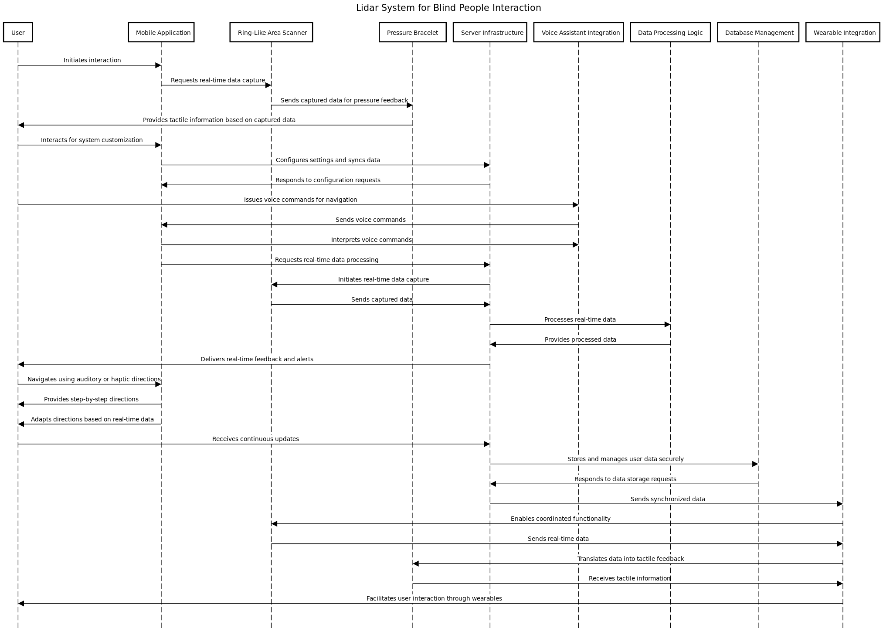

* + 1. **Interaction Diagram Key Details** 
       - * User initiation: The mobile application is where communication starts.
         * Real-time data collection: A Ring-Like Area Scanner provides real-time data requests to the mobile app.
         * Feedback through touch: The Pressure Bracelet receives data from the scanner to provide tactile feedback.
         * Personalization: Using the mobile application, users can customise the system.
         * Server communication: For configuration and data synchronization, the mobile app speaks with the server infrastructure.
         * Voice command navigation: By utilizing Voice Assistant Integration, users can navigate using voice commands.
         * Voice command processing: Real-time data processing and voice command interpretation are handled by the mobile app.
         * Updates are provided to the user continuously by the server infrastructure.
         * Adaptive directions: Using data from real-time sources, the mobile application provides adaptive, step-by-step instructions.
         * Data storage: Server Infrastructure uses Database Management to safely store and handle user data.
         * Synchronized data exchange: Wearable integration, Ring-Like Area Scanner, and Server Infrastructure all exchange data.
         * Translation of data into tactile feedback for the Pressure Bracelet is done via wearable integration.
         * Wearable interaction: By integrating wearables, wearable integration enables user interaction.

* 1. **Architectural Views**
     1. **Architectural View 1 Logical**
* **Introduction: Architectural View 1 Logical**
  + Pivotal Design: In order to address specific mobility challenges, especially for visually impaired users, the logical architectural view and interaction diagram of the LIDAR system for people with disabilities represent an essential first step.
  + Technological Innovation: The LIDAR system aims to improve the safety and independence of people with disabilities by utilizing cutting-edge technology and creative design principles.
  + Inclusive Solutions: The need for inclusive solutions that enable people with disabilities to navigate with confidence and independence is what motivated the development of this system.
  + Limitations of Traditional Aids: The progressive and adaptive LIDAR system is required because traditional mobility aids frequently lack comprehensive environmental awareness, particularly in dynamic or unfamiliar settings.
  + Systematic Approach: The logical architectural view and interaction diagram that are presented demonstrate the methodical and careful approach that was used in the creation of the LIDAR system.
  + Structural and Functional Understanding: This documentation contributes to the system's effectiveness and user acceptance by outlining the structural and functional aspects, which lay the groundwork for understanding the complex interactions between hardware, software, and user interaction.
  + Technical Expertise and Inclusivity: The diagrams demonstrate the LIDAR system's technical prowess while also demonstrating a dedication to accessibility, inclusivity, and user-centric design.
  + Deeper Exploration: The purpose of this assignment is to go deeper into the workings of the system and clarify how important it is to transforming the way people with disabilities travel.
* **Diagram:**

# 

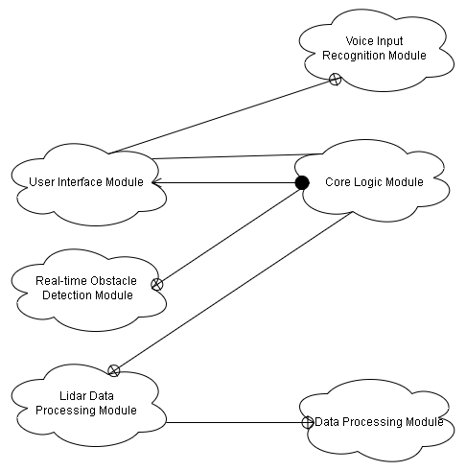

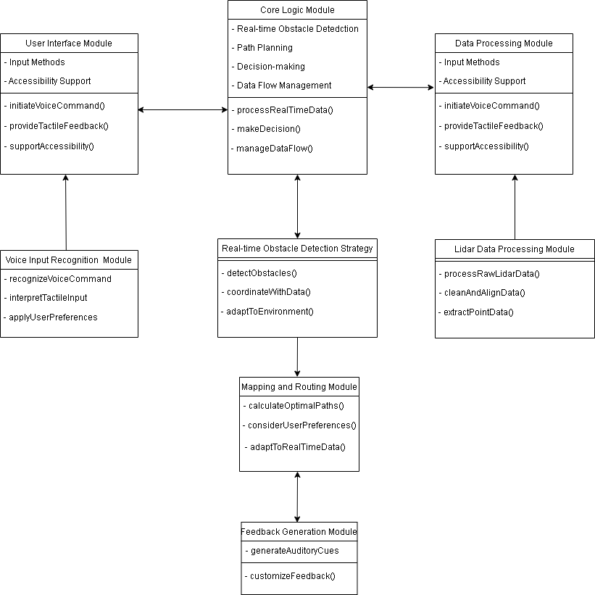

* **Key Details**
  + Core Logic Module:
    - The logical architectural view places emphasis on the central element coordinating the system's functionality and decision-making processes.
  + Module for User Interface:
    - The user interface module, which is centered in the architecture and is intended for people with disabilities, guarantees an approach to user-centric design that is both intuitive and accessible.
  + Module for Data Processing:
    - The data processing module is crucial because it performs real-time analysis and interpretation of LIDAR data to produce insightful findings that improve user situational awareness. This is highlighted by the logical view.
  + Voice Recognition Module:
    - Enhancing accessibility and usability, a voice input recognition module is incorporated into the architecture to enable users to interact with the system via voice commands.
  + Real-Time Obstacle Detection Strategy:
    - To improve user safety and navigation, a strategy for real-time obstacle detection is outlined in the logical view. This strategy guarantees the prompt and precise identification of obstacles.
  + LIDAR Data Processing Module:
    - To effectively support user navigation, the architecture incorporates a dedicated module for LIDAR data processing, which makes it easier to capture and analyze environmental data in a comprehensive manner.
  + Mapping and Routing Module:
    - Based on LIDAR data and user preferences, the mapping and routing module allows the system to provide users with optimized routes and navigation support. This module is highlighted in the logical view.
  + Feedback Generation Module:
    - An architecture-integrated module is in charge of providing the user with LIDAR data in an understandable manner. This improves the user's comprehension of their surroundings and encourages well-informed decision-making.
    1. **Architectural View 2 Physical**
* **Introduction: Architectural View 2 Physical**
  + Significant Advancement:
    - In addressing the particular mobility challenges faced by this user group, the physical architectural view of the LIDAR system designed for individuals with disabilities represents a significant advancement.
  + Making Use of Technology
    - It is the goal of the physical architectural view to improve the safety and independence of people with disabilities, especially the blind, by utilizing cutting-edge technology and creative design concepts.
  + Justification for Development:
    - This physical architectural view was developed in response to the pressing need for inclusive solutions that enable people with disabilities to move confidently and independently through their environment.
  + Shortcomings of Traditional Aids:
    - Traditional mobility aids often lack in providing comprehensive environmental awareness, especially in dynamic or unfamiliar settings. The physical architectural view serves as a progressive and adaptive solution surpassing the limitations of conventional assistive devices.
  + Methodical Approach:
    - The physical architectural view's introduction highlights the LIDAR system's development process' methodical and careful approach.
  + Distinguishing Between Structure and Function:
    - This documentation, which delineates the structural and functional aspects of the system, contributes to the system's effectiveness and user acceptance by laying the groundwork for understanding the complex interactions between hardware, software, and user interaction.
  + Symbol of Technical Prowess:
    - The physical architectural view represents a dedication to inclusivity, accessibility, and user-centric design in addition to the technical prowess of the LIDAR system.
  + Further Exploration:
    - With this conversation, we hope to go farther into the details of the physical architectural view and clarify how important it is to transforming the way people with disabilities move around.
* **Diagram**

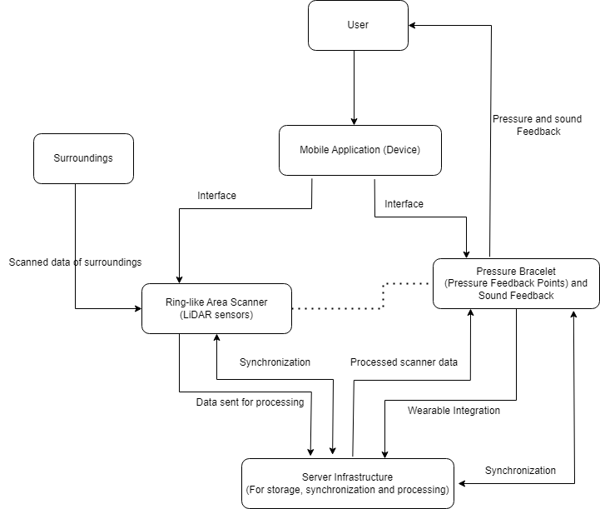

* **Key Details**
  + User-Centric Focus: The user, who represents people with disabilities who use the LIDAR system for navigation, takes center stage as a central element in the physical architectural view.
  + Mobile Application Integration: Adding a mobile application device to the LIDAR system allows users to access and interact with it via a recognisable and portable interface, signifying the integration of modern technology.
  + Dynamic Surroundings: Comprising the dynamic environment in which the LIDAR system functions to deliver real-time environmental data and navigation support, the surroundings are an essential part of the physical architectural view.
  + Ring-Like Area Scanner: Packed with LIDAR sensors, this scanner is essential for gathering environmental data in its entirety. It makes it possible for the system to identify obstructions and give the user spatial awareness.
  + Pressure Bracelet: By offering tactile feedback based on LIDAR data, the pressure bracelet improves the user experience. It has pressure feedback points and surround feedback. Safety and situational awareness are enhanced as a result.
  + Server Infrastructure: Within the physical architectural view, the server infrastructure is essential for data processing, synchronization, and storage. It makes sure that LIDAR data is integrated seamlessly and makes real-time analysis easier to support user navigation and decision-making.
    1. **Architectural View 3 Development**
* **Introduction: Architectural View 3 Development**
  + Crucial Development Step: The LIDAR system's development architectural view, customized for people with disabilities, represents a critical step in addressing specific mobility challenges.
  + Leveraging Technology and Design Innovation: The development architectural view seeks to improve the safety and independence of people with disabilities, especially those who are visually impaired, by utilizing innovative design principles and state-of-the-art technology.
  + Justification for Development:Developing this system is motivated by the pressing need to find inclusive solutions that enable people with disabilities to travel independently and with confidence.
  + The limitations of traditional mobility aids include their inability to provide a thorough understanding of the surroundings, particularly in dynamic or unfamiliar environments. The development architectural viewpoint presents itself as an adaptable and progressive fix.
  + Methodical Approach: The development architectural view's introduction highlights the LIDAR system's creation process' methodical and careful approach.
  + Delineation of Structural and Functional Aspects: This documentation provides a strong basis for understanding the complex interactions between hardware, software, and user interaction by clearly defining the structural and functional aspects.
  + Symbol of Technical Prowess: The development architectural view embodies a dedication to inclusivity, accessibility, and user-centric design in addition to representing the LIDAR system's technical prowess.
  + Deeper Exploration Goal: With this project, we hope to delve deeply into the system's intricacies and clarify its critical role in transforming the mobility experience for people with disabilities.
* **Diagram**

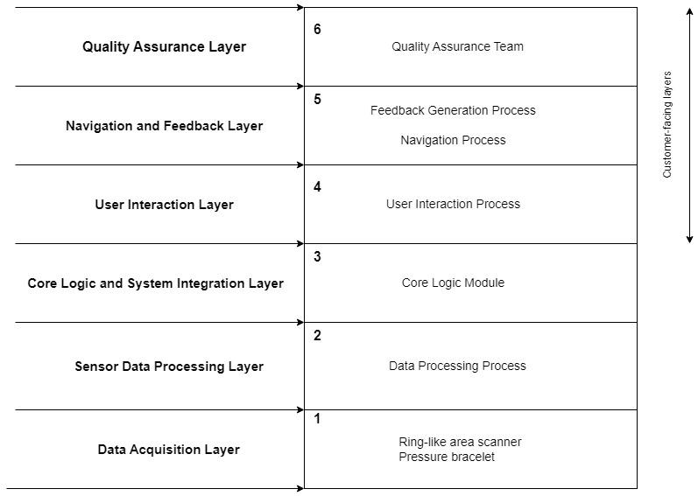

* **Key Details**
* Quality Assurance Layer:
* Components:
  + Utilization of automated testing frameworks.
  + Implementation of manual testing processes.
  + Integration of continuous integration and deployment tools.
  + Deployment of performance testing tools.
  + Adoption of code review and analysis tools.
* Functions:
  + Assurance of software quality and reliability.
  + Validation of compliance with coding standards.
  + Identification and resolution of bugs and vulnerabilities.
  + Monitoring and enhancement of system performance.
  + Navigation and Feedback Layer:
* Components:
  + Incorporation of user interface elements (menus, buttons, etc.).
  + Implementation of navigation algorithms.
  + Establishment of feedback mechanisms (alerts, notifications, etc.).
  + Integration of user preferences and settings.
* Functions:
  + Provision of intuitive navigation paths.
  + Gathering and presentation of user feedback.
  + Management of user input and interactions.
  + Personalization of user experiences based on preferences.
* User Interaction Layer:
* Components:
  + Integration of user interface components (UI).
  + Processing of user input.
  + Execution of user authentication and authorization.
  + Administration of user profile management.
* Functions:
  + Facilitation of user interactions with the system.
  + Administration of user authentication and access control.
  + Tailoring of user experiences.
  + Management of user input and requests.
  + Core Logic and System Integration Layer:
* Components:
  + Integration of business logic components.
  + Establishment of integration interfaces and APIs.
  + Implementation of workflow management.
  + Management of database access.
* Functions:
  + Execution of core business processes.
  + Integration with external systems and services.
  + Administration of data storage and retrieval.
  + Orchestration of system workflows.
  + Sensor Data Processing Layer:
* Components:
  + Establishment of sensor data acquisition interfaces.
  + Implementation of data preprocessing and filtering.
  + Execution of real-time data processing algorithms.
  + Deployment of data analytics and visualization tools.
* Functions:
  + Gathering and processing of data from sensors.
  + Analysis and extraction of insights from sensor data.
  + Real-time monitoring and reporting.
  + Visualization of sensor data for users.
  + Data Acquisition Layer:
* Components:
  + Integration of sensors and data sources.
  + Adoption of communication protocols.
  + Implementation of data acquisition devices.
  + Utilization of data storage solutions.
* Functions:
  + Capturing data from various sources.
  + Ensuring data accuracy and reliability.
  + Administration of data storage and retrieval.
  + Management of communication between devices and systems.

1. Detailed Design
   1. System Context and Interactions

* Overview

This segment conducts an extensive examination of LidarView's design elements, meticulously scrutinizing its hardware, software, and crucial modules like the User Interaction and Feedback Module. Through the utilization of visual aids, including UML diagrams, it provides a visual representation of the system's architecture, highlighting the vital role played by the LidarSensor in the real-time capture and processing of data.

The narrative places significant emphasis on fostering a seamless and inclusive user experience, with a dedicated focus on catering to individuals with disabilities. This emphasis ensures their smooth integration into the wider system design, promoting intuitive interaction and effective feedback mechanisms to enhance user engagement.

Furthermore, this section underscores the intricate integration of the User Interaction and Feedback Module within the LidarView architecture. It accentuates the module's pivotal role in facilitating user engagement through accessible design and adaptive functionalities. By seamlessly assimilating into the system's framework, this module guarantees real-time responsiveness and personalized interaction. This alignment with the system's overarching goal emphasizes inclusive and intuitive engagement for all users, particularly those with diverse accessibility needs.

* System Context Diagram

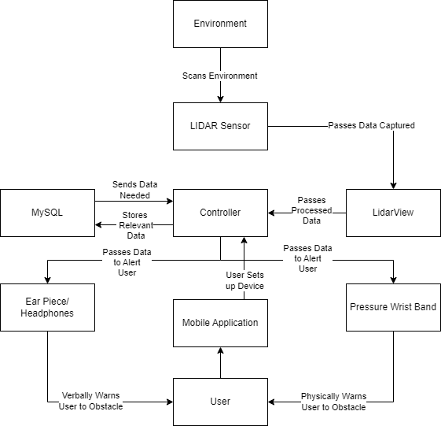

5.1.1 Design Element 1 : LidarView

* Overview:

LidarView is a comprehensive system integrating advanced Lidar technology for real-time environmental sensing and user interaction. This design element focuses on providing users with an inclusive and intuitive experience, combining accessibility, usability, and responsiveness to changing environmental conditions.

* Technical Details:
  + **Lidar Sensor Integration:**

Utilizes cutting-edge Lidar sensors for accurate environmental data capture. It Integrates seamlessly with LidarView architecture for real-time data processing.

* + **User Interaction and Feedback Module:**

Employs adaptive design elements for menus, buttons, and navigation. Which Incorporates navigation algorithms for obstacle-aware routing. Provides auditory and tactile feedback through earpieces/headphones and a pressure wristband.

* + **Customization and Preferences:**

Allows users to personalize their experience through customization options. This Enables voice command configuration, influencing the system's response during navigation.

* + **Integration with LidarView Architecture:**

Real-time data from Lidar sensors influences adaptive feedback and user guidance. Prioritizes accessibility, usability, and responsiveness for a holistic user experience. Ensures efficient communication and functionality within the broader LidarView system.

* Use Case Diagram and Use Cases:

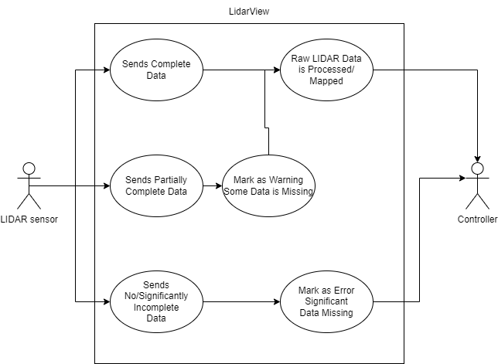

* Class Diagram and Sequence Diagrams:

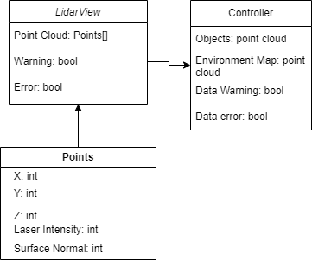

* Supporting UML and details:

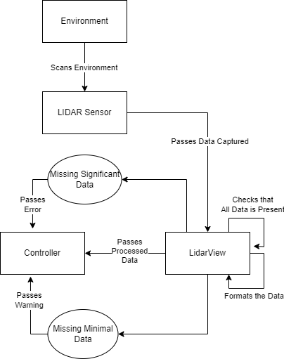

LidarSensor Interaction with the Environment:

The LidarSensor operates by emitting laser beams that traverse the surrounding environment, interacting with various objects and surfaces. These emitted beams generate reflections upon encountering objects, and the sensor captures these reflections for further analysis.

Upon capturing the reflected signals, the LidarSensor converts this data into a three-dimensional point cloud representation. This point cloud effectively maps out the spatial distribution of objects and obstacles present within the sensor's range, providing a detailed understanding of the environment.

The LidarSensor efficiently transmits the real-time point cloud data to the LidarView system for subsequent processing and analysis. This transmitted data includes crucial information such as the location, size, and distance of objects detected within the environment, enabling the system to make informed decisions based on this comprehensive spatial data.

5.1.2 Design Element 2 : User Interaction and Feedback Module

* Overview:

The User Interaction and Feedback Module in LidarView is a pivotal component designed to facilitate seamless engagement between individuals with disabilities and LIDAR technology. It prioritizes accessibility, usability, and real-time interaction, offering menus, buttons, and navigation tailored for diverse abilities. Adaptive algorithms ensure safe navigation, integrating obstacle-aware routing based on LidarSensor data. Users can personalize their experience through customizable settings and voice commands, fostering inclusivity. Seamlessly integrated into LidarView, this module prioritizes real-time responsiveness, ensuring users receive timely feedback during navigation, creating an empowering user experience within dynamic environments.

* Technical Details:

User interface elements such as Menus, buttons, and navigation are meticulously crafted for accessibility, catering to users with diverse abilities. They support intuitive interaction and adapt to various input methods like touch gestures, voice commands, and tactile feedback.

Navigation Algorithms: Utilizing real-time LIDAR data, the module generates adaptive step-by-step directions. It integrates obstacle-aware routing, ensuring safe and efficient navigation through dynamic environments.

The Pressure Wristband translates LIDAR data into tactile feedback, enhancing user situational awareness. Auditory feedback through earpieces or headphones delivers vital navigation instructions and obstacle alerts, enriching the user experience.

Users can personalize their experience through customization options, adjusting settings to suit individual preferences. Voice command configurations allow users to tailor the system's response during navigation.

Integrated into the broader LidarView architecture, the module communicates efficiently with real-time LidarSensor data. This integration emphasizes accessibility, usability, and real-time engagement:

Crafted with a focus on inclusivity, the platform is designed to cater to diverse user requirements, emphasizing accessibility and functionality. It integrates adaptable features and customizable options to ensure a seamless and user-friendly interface. This dynamic system promptly adjusts to varying environmental circumstances, delivering timely and pertinent feedback throughout navigation for a real-time interactive experience.

* Use Case Diagram and Use Cases:

# 

* Class Diagram and Sequence Diagrams:
  + Class Diagram:

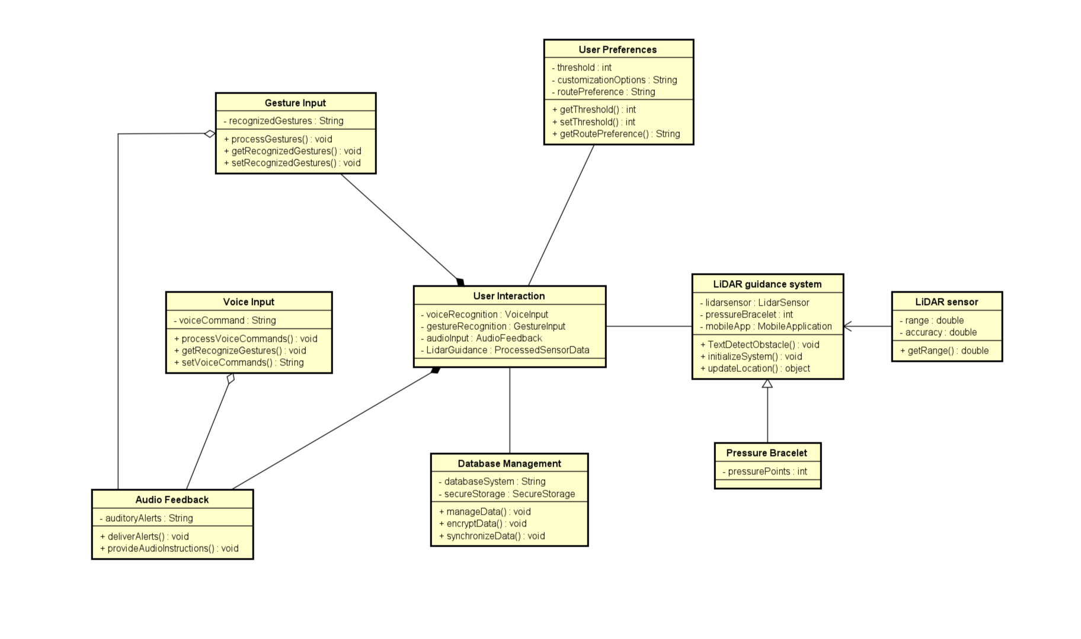

* + Sequence Diagram:

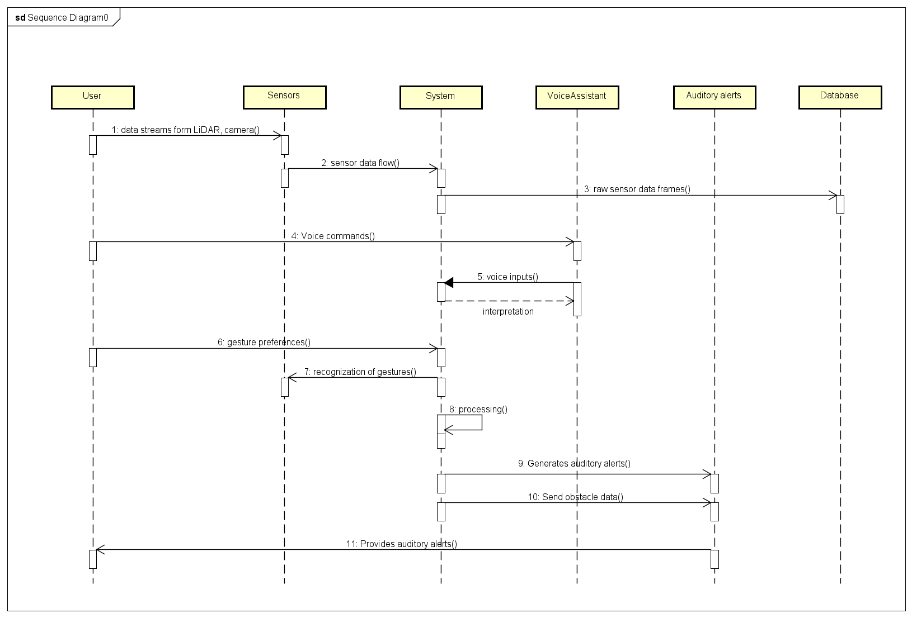

The sequence begins with the user engaging via the LidarView Mobile Application, prompting voice-commanded navigation and customization preferences. The Mobile App triggers real-time sensor data requests, processed by the LidarView system to identify obstacles and pathways. Simultaneously, the user adjusts settings through the Mobile App while receiving auditory alerts via earpiece/headphones and tactile feedback through the Pressure Wristband. The system updates preferences securely, ensuring continuous real-time feedback and customizable interactions.

5.1.3 Design Element 3 : Adjusting System Preferences

* Overview:

The Adjusting System Preferences module within LidarView serves as a pivotal component, fostering enhanced user engagement and personalized experiences, particularly catering to individuals with disabilities. It stands as a cornerstone feature, offering users a comprehensive range of personalization options. From tailoring the overall user experience to refining navigation methods, voice commands, and feedback modalities, this module empowers users to customize settings according to their unique preferences.

At its core, the module emphasizes accessibility by enabling an adaptive user interface and customizable alerts, catering to diverse input methods and sensitivities. Voice command configurations further enrich the user experience, ensuring intuitive voice interactions. Integrated seamlessly with the User Interaction and Feedback Module, this preference-adjusting feature aligns with a user-centric design philosophy, dynamically shaping guidance and feedback in real-time. Fundamentally, this module embodies LidarView's commitment to inclusivity and user empowerment, aiming to provide individuals, especially those with disabilities, the autonomy and confidence to navigate their surroundings with ease.

* Technical Details:

The module empowers users through a spectrum of personalization options. It enables the customization of various system settings, ensuring a personalized and adaptive user experience with LidarView technology. Users can define preferences related to navigation methods, voice command configurations, and feedback modalities, tailoring their interaction according to individual needs and preferences.

Within the realm of accessibility, the module offers an adaptive user interface, allowing adjustments to UI elements to accommodate diverse input methods and accessibility requirements. Furthermore, users can fine-tune alerts based on type and intensity, catering to a wide range of user sensitivities and preferences.

Voice command configurations provide a personalized touch to interactions with LidarView. Users have the flexibility to set preferences, influencing how the system responds to spoken instructions, thus ensuring a more intuitive and user-friendly experience.

Integration with User Interaction Module:

This module seamlessly integrates with the broader User Interaction and Feedback Module, contributing to a cohesive and user-centric design philosophy. It allows individuals to tailor their interaction with LidarView, aligning with a user-centric approach. Preferences set within this module dynamically influence adaptive guidance, feedback, and the overall user experience in real-time, ensuring instant responsiveness and enhancing accessibility for users, especially those with disabilities.

User Empowerment and Inclusivity:

The Adjusting System Preferences module underscores LidarView's commitment to user empowerment and inclusivity. Recognizing the uniqueness of individual preferences and requirements, the module aims to empower users with disabilities, granting them the confidence and autonomy to navigate their surroundings comfortably.

By offering customization options, the module supports enhanced accessibility, addressing the diverse needs of users and reinforcing LidarView's commitment to inclusivity and user-centric design principles.

* Use Case Diagram and Use Cases:

# 

* Class Diagram and Sequence Diagrams:
  + Class Diagram:

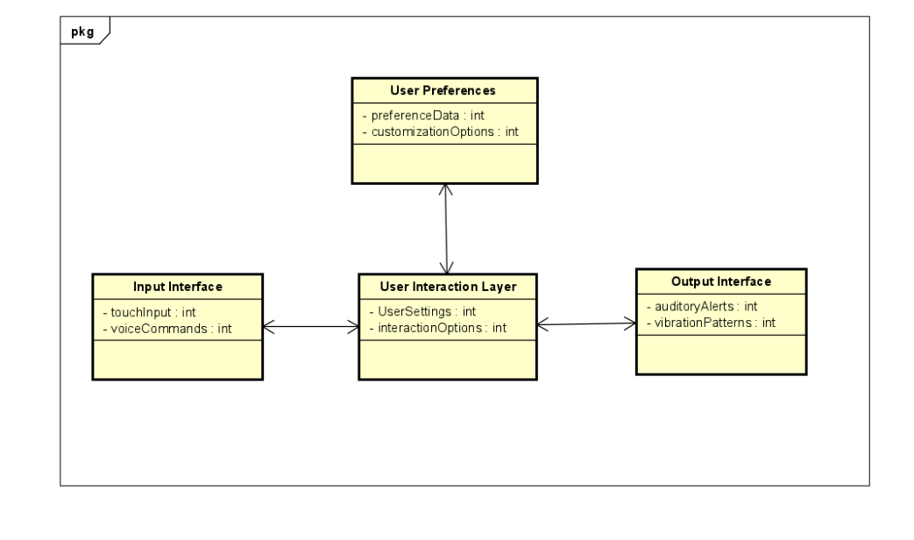

* + Sequence Diagram:

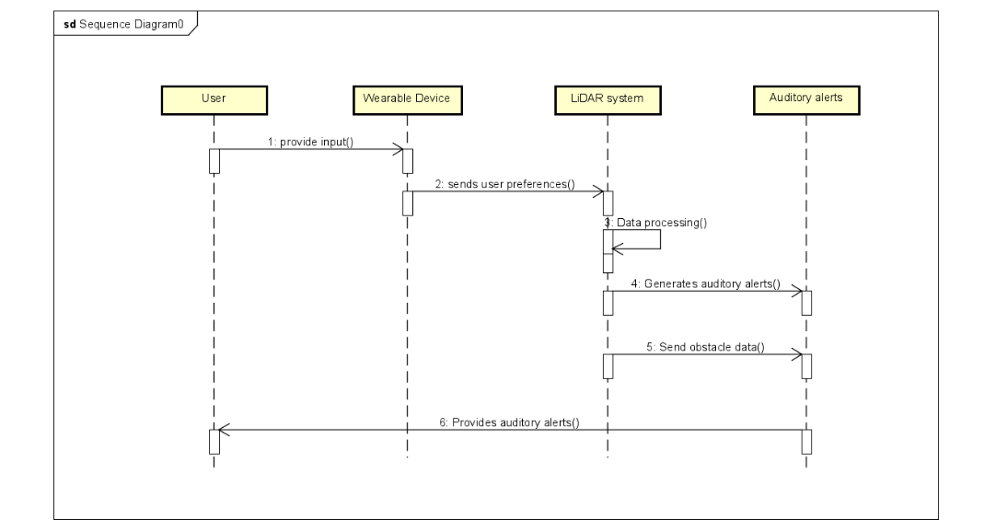

1. Implementability
   1. Overview

The system can be broken down into two main sections being hardware and software. First looking at the hardware we have the headpiece and the wristband. The headpiece would simply be a hat/beanie with a Lidar sensor on top with a bluetooth chip, some memory, a processor, open-ear headphones, and a power source. This idea mimics that of self-driving cars, with the Lidar sensor on top to map the surroundings. The wristband would be a tight rubber wristband with vibration motors, a bluetooth chip, and a power source. The hat can be seen here:

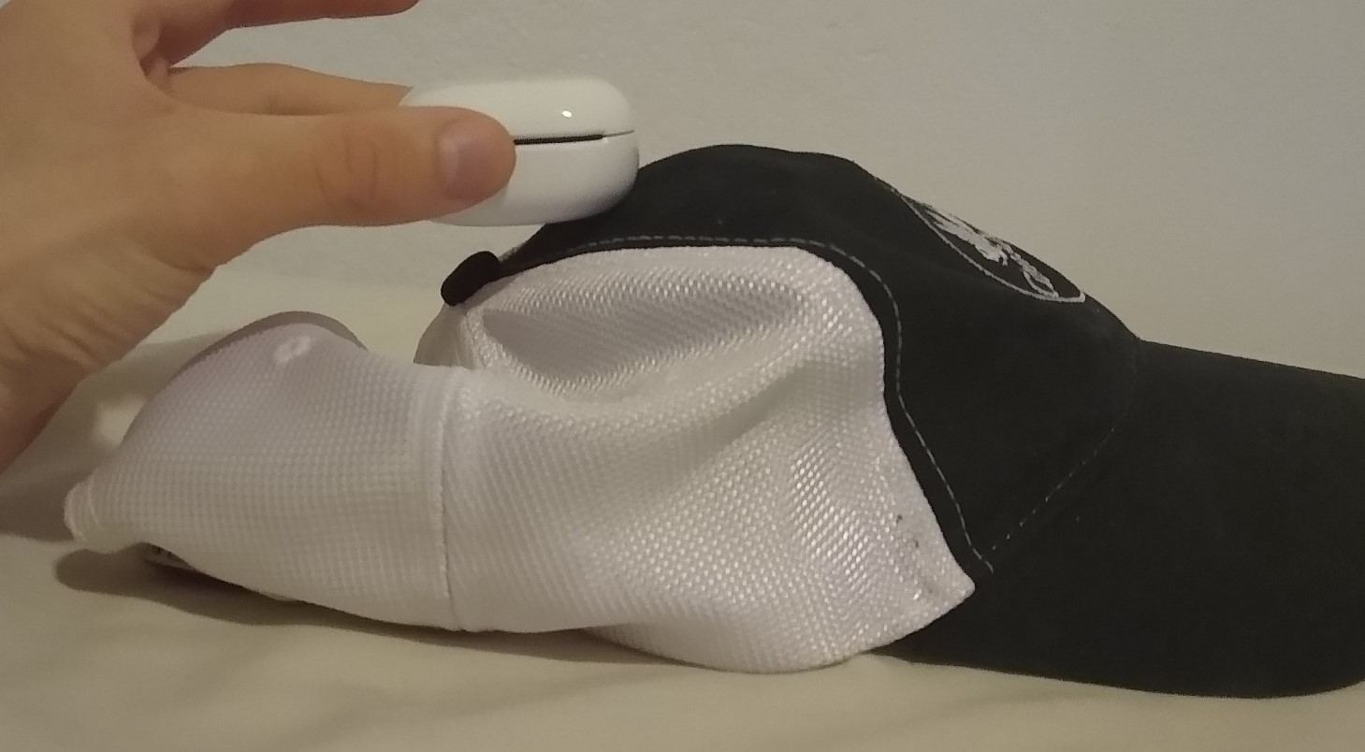

The wristband can be seen here:

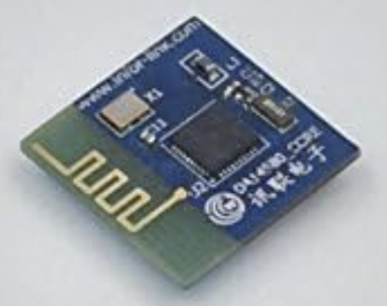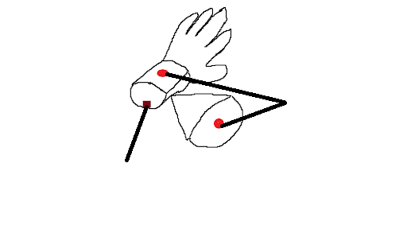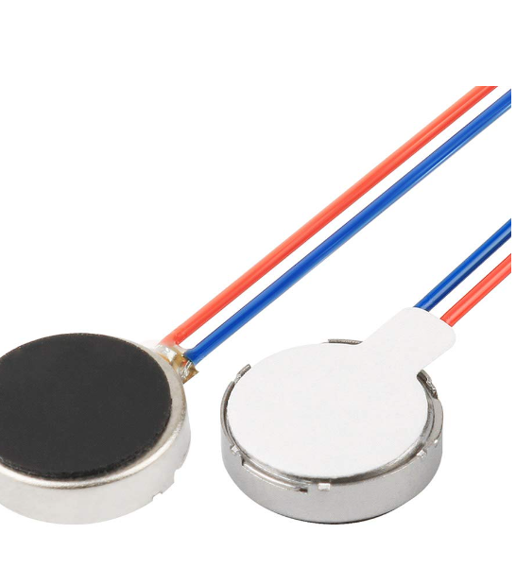

The software would then be split into the reuse portions and the portions we would have to make ourselves. The reuse portion such as the LidarView would be used to process the data produced by the Lidar sensor. We would then have to make code to interpret the data map produced by LidarView and send signals to the open-ear headphones and the wristband.

The hardware components are made of many reuse components and would only require an engineer to take the time and make a functional design for both components. The software would only require some programmers to make a program that inputs a data map from LidarView and outputs signals to alert the user. These alerts would vary from a simple vibration in the wristband to verbal warnings.

We have already selected many of the components. Here is a list of links to those components:

Lidar: <https://www.adafruit.com/product/4010#description>

Bluetooth chip: <https://www.amazon.com/DA14580-smallest-bluetooth-module-Bluetooth/dp/B071VG5RMC>

Open-ear headphones: <https://www.amazon.com/Siniffo-Conduction-Headphones-Microphones-Waterproof/dp/B0C7ZRWM8S/ref=sr_1_5?crid=2T5WGFSO2ROHW&keywords=earless+headphones+bluetooth&qid=1700619486&s=electronics&sprefix=earless%2Celectronics%2C255&sr=1-5>

Vibration Motors: <https://www.amazon.com/gp/aw/d/B07Q1ZV4MJ/?_encoding=UTF8&pd_rd_plhdr=t&aaxitk=61d8218e1b3f57b4d17cbe302054003b&hsa_cr_id=5781348260601&qid=1700442140&sr=1-1-9e67e56a-6f64-441f-a281-df67fc737124&ref_=sbx_be_s_sparkle_mcd_asin_0_title&pd_rd_w=HP33t&content-id=amzn1.sym.417820b0-80f2-4084-adb3-fb612550f30b%3Aamzn1.sym.417820b0-80f2-4084-adb3-fb612550f30b&pf_rd_p=417820b0-80f2-4084-adb3-fb612550f30b&pf_rd_r=BWGRFRQJ5C06N5HXVYE1&pd_rd_wg=4ZWmu&pd_rd_r=c2f531d1-f7ce-469f-9fdf-82579b6f7561>

LidarView: <https://lidarview.kitware.com/>

* 1. Structure and Naming

Hat:

The hat will have a couple main elements: hat, LiDAR system, data storage, and a wireless bluetooth chip. These will all be powered by a rechargeable battery device. These will be fixed securely to an adjustable hat.

The LiDAR element will be used to collect the necessary data to make a map of the surroundings that will be stored within the data storage element. The data storage element will store all recent maps collected from the LiDAR element and will be called from to compare the maps to determine speed and direction of the user and potential moving objects. The hat will be used to secure the device to the user’s head in an adjustable way. Finally, the bluetooth chip will be used to communicate with other exclusively connected devices that will be used to communicate more directly with the user.

Bracelet:

The bracelet would have 3 main elements to enable the functionality required. The first element would be the 2 vibration motors that it would have, with one on top of the wrist and one on the bottom of the wrist. These motors are the way in which we warn the user of objects that are in their path and the recommended actions they should take. With vibrations from the motors we can warn the user to turn left, right, or stop.

The next element is the bluetooth chip. The bluetooth chip is used to receive the signals from the controller. It is the way in which the bracelet knows which motor to vibrate and the intensity of that vibration. The bluetooth chip would be exclusively paired with the headset so as to help improve security by keeping it a closed system.

The third element is the bracelet itself which will be a tight rubber bracelet. This is to help ensure that the user is warned properly as this helps them identify the vibration and which motor it came from. If the bracelet was loose then it could be hard to feel the vibration or identify which motor it came from.

* 1. Use Case Implementability Analysis and Rationale

**LiDAR Hat:**

| Use Case ID | 1.0.0 |
| --- | --- |
| Case Name | Bracelet Feedback |
| Created By | [Alexander Chittim](mailto:achittim@asu.edu) |
| Date Created | 11/1/2023 |
| Actor | Wearable Hat with a LiDAR sensor and bluetooth chip |
| Description | The System will scan the environment and locate potential hazards the user is heading towards |
| Preconditions | The LiDAR sensor and the bluetooth chip are connected correctly and there are no connectivity issues. There is appropriate power for the device. Always receives a message back |
| Post Conditions | Feedback is confirmed to have been received from another device |
| Primary Pathway | The system has scanned the surroundings and found that the current path of the user is heading for a stationary object within 9ft and that they need to correct their course. The system will send out the left, right, stop instruction and receive a message that the message was received. |
| Alternate Pathway | The user is heading into the path of a moving object. The system compares maps to know if the object is moving and its path. calculates the time the user has before running into the object. Send the message to alert the user. Message is received back. |
| Exception Pathway | The system does not detect that the user is going to run into something. Comparing of maps still happens but no message is sent out |
| Notes and Issues | Could be a problem for objects continually changing their speed  does not know about objects blocked by other objects |

**Bracelet:**

| Use Case ID | 1.0.1 |
| --- | --- |
| Case Name | Bracelet Feedback |
| Created By | Brenden Martinez |
| Date Created | 11/1/2023 |
| Actor | Wearable Bracelet and visually impaired individual |
| Description | The system will send feedback to the user when they are close to running into an object. |
| Preconditions | The bracelet is connected to the rest of the system and there is nothing that will prevent a connection. There is something in the user path and it needs to send feedback |
| Post Conditions | The bracelet feedback causes the user to change their current path |
| Primary Pathway | The system has detected something, the device then checks the connection to the bracelet, and when connected it will send the feedback to the bracelet that will inform the user of what action to take, the user changes course. The bracelet sends confirmation that it received the information |
| Alternate Pathway | The user does not change path, once it sends the confirmation that it did receive the information, the system will reissue the feedback which the bracelet will then repeat twice. This will be repeated until the user changes course to not run into something |
| Exception Pathway | The system cannot connect to the bracelet it will have to first search for the bracelet reinstate the connection and do the primary pathway  The system is continually unable to connect to the bracelet; it will retry until a connection is established. The system will inform the user it cannot find the bracelet |
| Notes and Issues | This could have problems with crowds of people  if it cannot connect to the bracelet it is because the bracelet and the device are not in range |

* 1. Implementability Details

**Hat with LiDAR:**

The hat with a 360 LiDAR sensor is used to collect and analyze data to determine if the user is going to run into an object. This is accomplished by having the LiDAR sensor continually send out laser pulses to collect data. Using that data it will create a map around the user showing solid objects. These maps will be stored and used to be compared against previous maps to calculate the users current speed and direction they are heading. Based on the user's speed and direction it will be used to determine if objects are moving or stationary as they are treated differently. An example of a simulate LiDAR collected data is shown in this video: <https://www.youtube.com/watch?v=JbUNsYPJK1U> starting from 4:00 to end.

The system will check 3m or 9ft around the user to check for stationary objects that are within the user's path. If there is no object then no alert is sent, otherwise it will determine which direction best avoids the object. This is done by left, right or stop. The message will be sent using a bluetooth chip to the connected device that will be used to alert the user which in this case is a bracelet. depending on the closeness of the object the urgency of the directions will be communicated.

For moving objects it will use the max range of the LiDAR sensor (12m/40ft). These will be identified by comparing maps created and finding points/objects that have moved significantly regardless of the users current speed. It will use the change of object by comparing the maps to determine the object's speed and direction. After finding the speed and direction of all moving objects it will see if the object is heading for the user or the user’s path. The system will use an equation taking into account the object's speed and the user's speed to determine when the user will be alerted to the object's presence. The faster the object is moving the sooner and more urgent it is to alert the user about it. Then it will send the appropriate message.

All moving objects will be stored and tracked even after it is outside the LiDARS range. They will be forgotten after x time based on direction and speed of the object relative to the user.

All messages will be sent out from a wireless bluetooth chip that will be connected to another bracelet system. The bracelet will be the part that will interact with the user. The message will include all the information needed to communicate intensity of the vibration, direction (left or right), stop, and the number of necessary buzzes.

**Bracelet:**

The bracelet is used to warn the user of obstacles that are in the user's path. The user will be warned of objects within 3 meters that are the path of the whether that be stationary or slow moving objects. The user will also be warned of fast moving objects, such as cars or bikes, within 12 meters that will collide with their path, so as to give the user adequate time to react. The bracelet will warn the user with 2 vibration motors. One on top of their wrist to tell the user to turn to the right, and then one on the bottom of their wrist to tell the user to turn to the left. The intensity of the vibration will tell the user how sharp of a turn they need to make. Both vibration motors will vibrate to signal to the user to stop. All these warnings will be sent to the bracelet by the controller through a bluetooth chip.

1. Presentations
   1. Overview Screencast
      * + - Team Presentation - All Team Members

<https://drive.google.com/file/d/1g-5ZalY1_eGBXl8a6F0XYU3YtqDWzkoC/view?usp=sharing>

* 1. Detailed Presentation of Flow and Implementability
     + - * System Architecture - Parv Shah

<https://drive.google.com/file/d/1BMA-w3wXh9-JHASuOCELfzcdXJU4ZD8G/view?usp=sharing>

* + - * + Vibration Bracelet - Alexander Chittim <https://drive.google.com/file/d/1ccZCpVV2Hdz1i4JDJ4_AJYzhAaQ77SYW/view?usp=sharing>
        + User Interaction and Feedback - Prathit Barot

<https://drive.google.com/file/d/11Z-yFdesu31wC5jx_hnDlQkQlSC6QaZe/view?usp=sharing>

* + - * + LidarView - Monil Rameshchandra Prajapati

<https://drive.google.com/file/d/1jYQa1OWuJgKlYjrfZtg_bgkPfpFcVEkd/view?usp=sharing>

* + - * + LiDAR hat Prototype - Brenden Martinez

<https://drive.google.com/file/d/1t7apTzuJLwz_OhpfyVg0MJohjDJyfdBe/view?usp=sharing>

1. Conclusion
   1. Overview

This report documents how we decided to take the issue of developing a cyber physical prototype that will be used to assist the visually impaired as they are navigating the world. The prototype we propose is a hat with a LiDAR sensor that will collect and map the users surroundings, identify obstacles, and communicate the best course of action to avoid those obstacles. This information will be communicated through the use of a bracelet with vibration motors.

* 1. Lessons Learned

Throughout this project we have learned the difficulty and importance of putting our ideas onto paper and knowing the specifics of the problems and our solution to solve this. This was learned part way through the semester as we were informed that through our reports we were not communicating what our project was accomplishing by the professor. This was solved through talking and getting feedback from the professor and meeting up as a group to make sure we were all on the same page and working together to clarify and provide concrete ideas in the form of a physical system.

* 1. Recommendations for Improvement

There are some improvements that we could make as a group to help make our project not only better but more impactful. The first one was more communication within the group of what the final product is and making sure that everyone in the group is on the same page. This could be easily accomplished by meeting more often and in person. This compounded the work we needed to do to meet expectations as we needed to rework and rewrite many sections of the report we had been building on. Secondly, talking with either the professor or TA about how concrete our ideas are and better understanding of the expectations instead of relying on a rubric.

1. Appendix A: Credit Sheet

| Team Member Name | Contributions |
| --- | --- |
| Monil Rameshchandra Prajapati | Section 3 Requirement  Section 5: Detailed Design |
| Parv Shah | Section 4: Architecture  Section 7: Presentation |
| Prathit Nilay Barot | Section 1: Problem Statement  Section 2 Vision  Section 3 Requirement |
| Brenden Martinez | Section 6: Implementability: Hat  Section 7: Presentation |
| Alexander Chittim | Section 6: Implementability: Bracelet  Section 7: Presentation |